OpenHRP All-Inclusive Parameters File

**Simulation Parts Location**

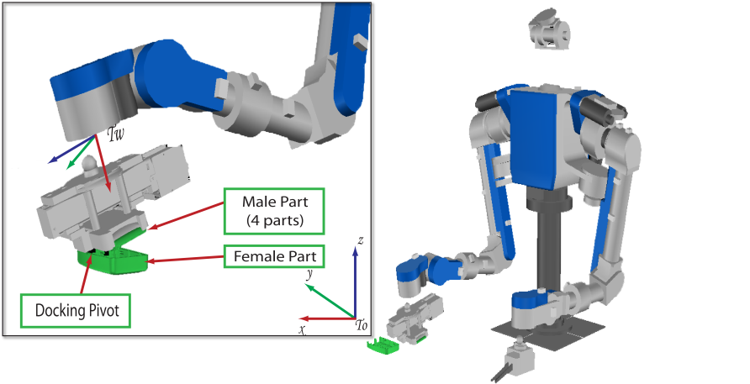*Simulation environment uses meters as standard units. Rotations are effected in terms of quaternions.*

* Robot Base
* Robot Wrist
* Robot EndEffector
* Female Part

Other Notes:

**Project Simulation XML File**

* To find the simulation file for the PivotApproach Snap Assembly using HIRO, open the file: “HRP2STEP1_Pivot_offset.xml” located at: ~/src/OpenHRP3.0/client/gui/project.
* This XML file loads 3 different figures:
  + Hiro Robot.
    - File location: $(OPENHRPHOME)/Controller/IOserver/robot/HRP2STEP1/model/main_pivot.wrl
    - Robot Base Position:  
      Waist Translation <0,0,0>; Waist Rotation <0,1,0,0>
    - Male Cam  
      The male cam is embedded inside the above xml file. The parameters for this simulation is found in the file named: upper_vrml97_10000_point.wrl.
      * rotation <-0.5774 0.5774 -0.5774 2.0944>   
        # obtained by trial and error
      * translation <-0.046000 -0.030000 -0.005000>
    - Note about Home Position for End-Effector  
      This is defined in the CPP files and it should be: <0.3324, -0.1722, 0.33692>
  + femaleCam
    - File location:  
      $(OPENHRPHOME)/etc/femaleCam.wrl
    - The simulation file for the female camera is referred to inside the .wrl file and is named: lower_vrml97_1000_point.wrl
    - Position:  
      Translation: <-0.068, 0.001, 0.029>, Rotation: <0,1,0,0>

**Controller Parameters**

*SideApproach*

* State 2
  + Desired Force (local coordinates)
  + Desired Moment (local coordinates)
* State 3
  + Desired Force
  + Desired Moment

**Waypoint Files**

*Side Approach*

* pivotApproachState1.dat <time,x,y,z,R,P,Y>
  + <2.50, 0.311, -0.1726, 0.542, 0.000, -1.2781, 0.000>
  + <4.50, 0.331, -0.1726, 0.531, 0.000, -1.2781, 0.000>
* pivotApproachState2.dat
  + Whenever, the threshold for contact during the Approach phase is triggered, a new file is written with the following data:
  + <cur_time+ROTATION_TIME_SLOW, pos(0), pos(1), pos(2,), 0.00, -1.5708, 0.00>